**Durak User Guide**

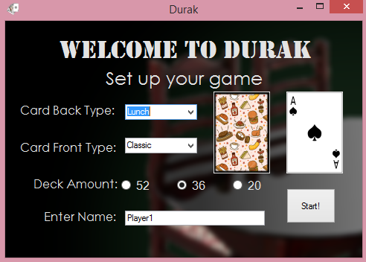

Menu: From the menu you can select what card back you would like to have for the game along with the font that the cards will use from the drop down menus. You can also select the number of cards that will be in the deck from the radio buttons. Finally you can enter in your name at the text box and start the game by hitting the start button.

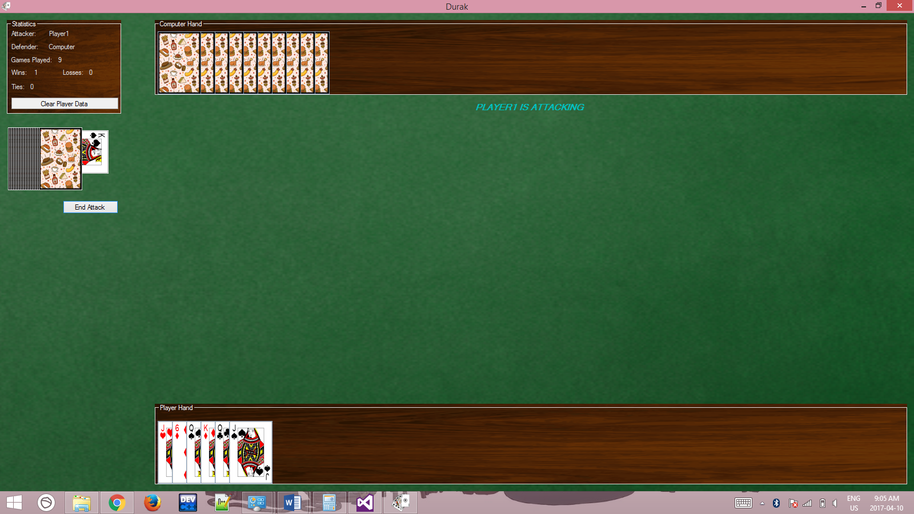

Game: The game will store that number of times you have won, lost and tied the computer in the game by storing it in a log file. You’re wins and losses will be carried over for the next time that you play the game. The raised card in your hand is the one selected when you click to play a card. You can press the end attack button to finish your turn when you are attacking.

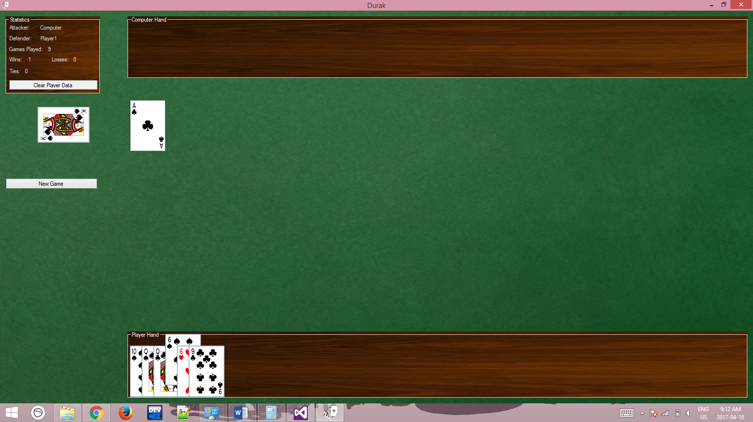

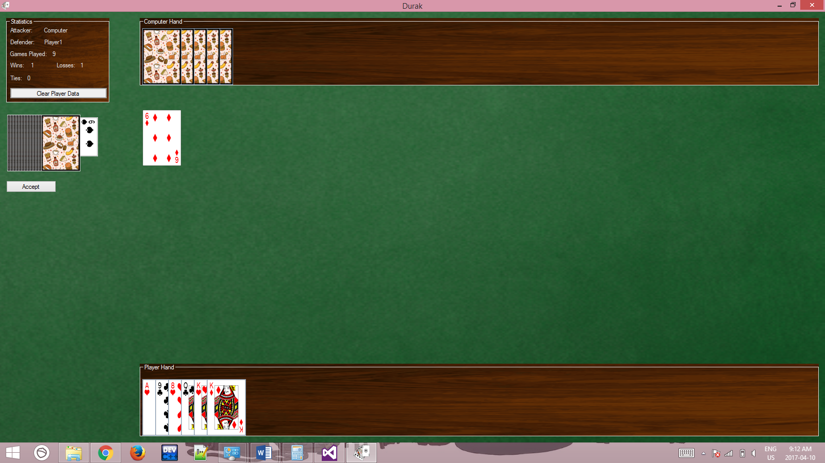

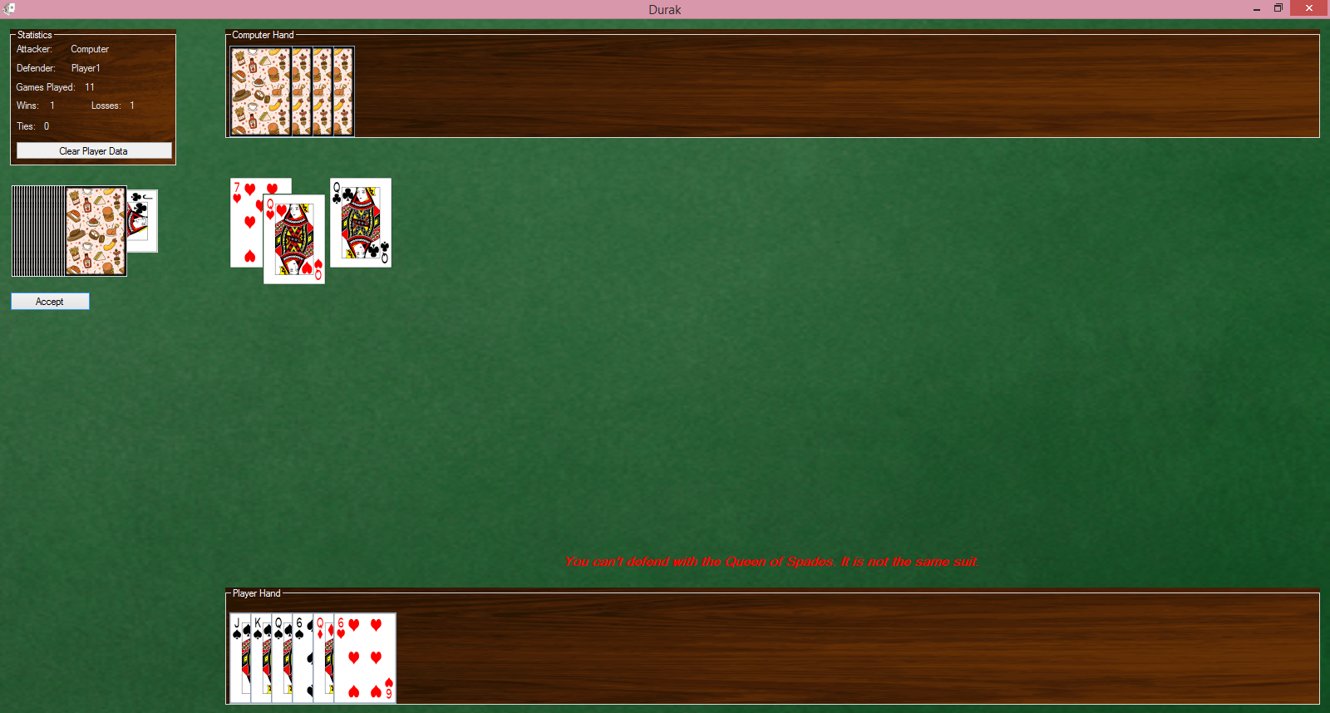

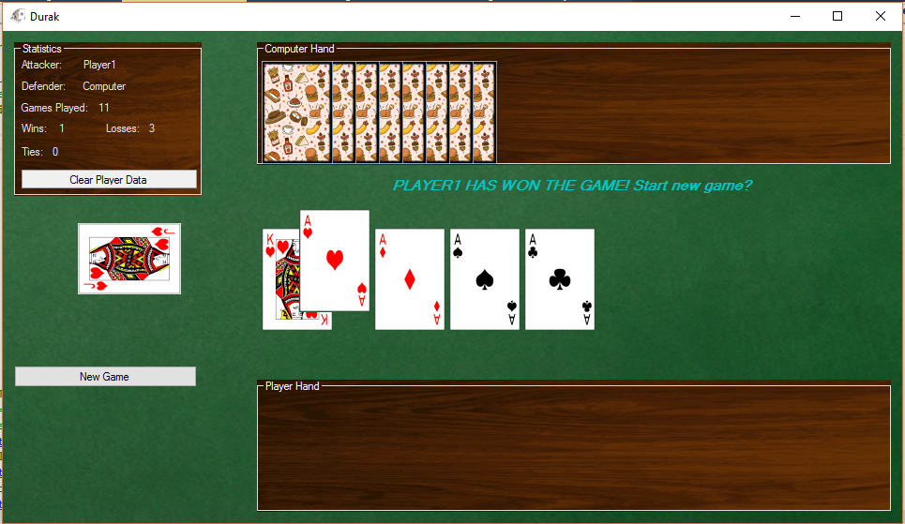

How to play: There is no winner In Durak there is only a loser. The loser is the last player to still have cards in there hand after the deck has been emptied. All players must have 6 cards in their hand at the start of the turn if a player does not have 6 cards they must draw from the deck until they do. You may have an unlimited amount of cards in your hand at a time. A trump card is drawn from the deck at the start of the game, the suit of that card is trump for the rest of the game. An attacker places down a card at the start of the turn he defender must place a card that has a higher rank then the card placed by the attacker. The defender must place a card of the same suit or trump suit. If the defender successfully defends the attacker must place a card that is the same rank as one of the other cards that has been played that turn. The turn goes until either the attack or defender can no longer place down a higher card. If the defender loses the round they must take all the cards placed on the table and add them to their hand. If the attacker loses the cards are discarded. If the attacker wins they may continue to place down additional cards that are the same rank as other cards that have been placed.